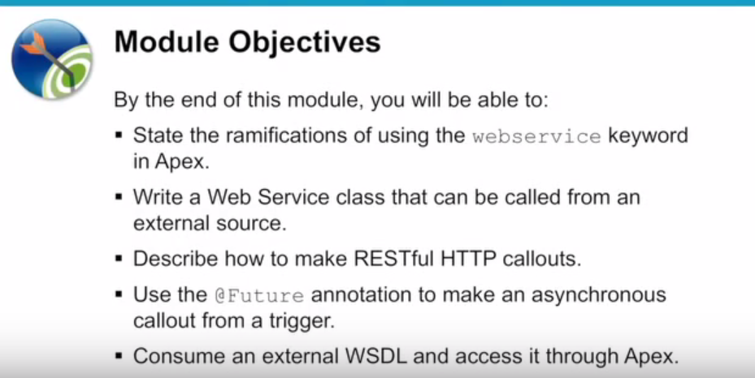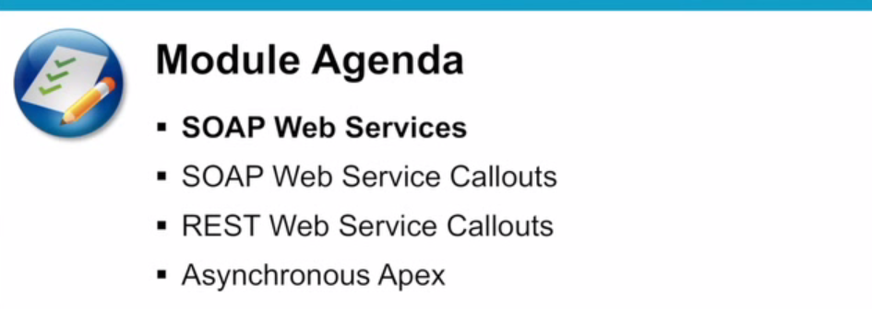

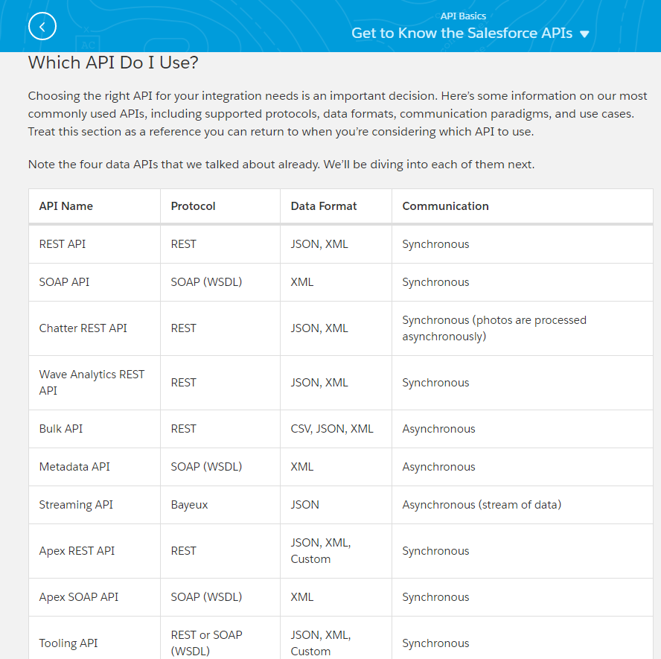

Which API Do I Use? | Salesforce

**Which API Do I Use?**

Salesforce provides programmatic access to your org’s information using simple, powerful, and secure application programming interfaces.

|  |
| --- |
| Available in: Salesforce Classic |
| Available in: **Enterprise**, **Performance**, **Unlimited**, **Developer**, and **Database.com** Editions |

| **User Permissions Needed** | | | | |
| --- | --- | --- | --- | --- |
| **To use the APIs** | | | “API Enabled” | |
| **API Name** | **Protocol** | **Data Format** | | **Communication** |
| REST API | REST | JSON, XML | | Synchronous |
| SOAP API | SOAP (WSDL) | XML | | Synchronous |
| Chatter REST API | REST | JSON, XML | | Synchronous (photos are processed asynchronously) |
| Wave Analytics REST API | REST | JSON, XML | | Synchronous |
| Bulk API | REST | CSV, JSON, XML | | Asynchronous |
| Metadata API | SOAP (WSDL) | XML | | Asynchronous |
| Streaming API | Bayeux | JSON | | Asynchronous (stream of data) |
| Apex REST API | REST | JSON, XML, Custom | | Synchronous |
| Apex SOAP API | SOAP (WSDL) | XML | | Synchronous |
| Tooling API | REST or SOAP (WSDL) | JSON, XML, Custom | | Synchronous |

**When to Use REST API**

REST API provides a powerful, convenient, and simple REST-based web services interface for interacting with Salesforce. Its advantages include ease of integration and development, and it’s an excellent choice of technology for use with mobile applications and web projects. However, if you have many records to process, consider using Bulk API, which is based on REST principles and optimized for large sets of data.

**When to Use SOAP API**

SOAP API provides a powerful, convenient, and simple SOAP-based web services interface for interacting with Salesforce. You can use SOAP API to create, retrieve, update, or delete records. You can also use SOAP API to perform searches and much more. Use SOAP API in any language that supports web services.

For example, you can use SOAP API to integrate Salesforce with your org’s ERP and finance systems. You can also deliver real-time sales and support information to company portals and populate critical business systems with customer information.

**When to Use Chatter REST API**

Use Chatter REST API to display Salesforce data, especially in mobile applications. In addition to Chatter feeds, users, groups, and followers, Chatter REST API provides programmatic access to files, recommendations, topics, notifications, Data.com purchasing, and more. Chatter REST API is similar to APIs offered by other companies with feeds, such as Facebook and Twitter, but it also exposes Salesforce features beyond Chatter.

**When to Use the Wave Analytics REST API**

You can access Wave Analytics assets—such as datasets, lenses, and dashboards—programmatically using the Wave REST API. Send queries directly to the Wave Platform. Access datasets that have been imported into the Wave Platform. Create and retrieve Wave Analytics lenses. Access XMD information. Retrieve a list of dataset versions. Create and retrieve Wave Analytics applications. Create, update, and retrieve Wave Analytics dashboards. Retrieve a list of dependencies for an application. Determine what features are available to the user. Work with snapshots. Manipulate replicated datasets.

**When to Use Bulk API**

Bulk API is based on REST principles and is optimized for loading or deleting large sets of data. You can use it to query, queryAll, insert, update, upsert, or delete many records asynchronously by submitting batches. Salesforce processes batches in the background.

SOAP API, in contrast, is optimized for real-time client applications that update a few records at a time. You can use SOAP API for processing many records, but when the data sets contain hundreds of thousands of records, SOAP API is less practical. Bulk API is designed to make it simple to process data from a few thousand to millions of records.

The easiest way to use Bulk API is to enable it for processing records in Data Loader using CSV files. Using Data Loader avoids the need to write your own client application.

**When to Use Metadata API**

Use Metadata API to retrieve, deploy, create, update, or delete customizations for your org. The most common use is to migrate changes from a sandbox or testing org to your production environment. Metadata API is intended for managing customizations and for building tools that can manage the metadata model, not the data itself.

The easiest way to access the functionality in Metadata API is to use the Force.com IDE or Force.com Migration Tool. Both tools are built on top of Metadata API and use the standard Eclipse and Ant tools, respectively, to simplify working with Metadata API.

* Force.com IDE is built on the Eclipse platform, for programmers familiar with integrated development environments. Code, compile, test, and deploy from within the IDE.
* The Force.com Migration Tool is ideal if you use a script or the command line for moving metadata between a local directory and a Salesforce org.

**When to Use Streaming API**

Use Streaming API to receive notifications for changes to data that match a SOQL query that you define.

Streaming API is useful when you want notifications to be pushed from the server to the client. Consider Streaming API for applications that poll frequently. Applications that have constant polling against the Salesforce infrastructure consume unnecessary API call and processing time. Streaming API reduces the number of requests that return no data, and is also ideal for applications that require general notification of data changes.

Streaming API enables you to reduce the number of API calls and improve performance.

**When to Use Apex REST API**

Use Apex REST API when you want to expose your Apex classes and methods so that external applications can access your code through REST architecture. Apex REST API supports both OAuth 2.0 and Session ID for authorization.

**When to Use Apex SOAP API**

Use Apex SOAP API when you want to expose Apex methods as SOAP web service APIs so that external applications can access your code through SOAP.

Apex SOAP API supports both OAuth 2.0 and Session ID for authorization.

**When to Use Tooling API**

Use Tooling API to integrate Salesforce metadata with other systems. Metadata types are exposed as sObjects, so you can access one component of a complex type. This field-level access speeds up operations on complex metadata types. You can also build custom development tools for Force.com applications. For example, use Tooling API to manage and deploy working copies of Apex classes and triggers and Visualforce pages and components. You can also set checkpoints or heap dump markers, execute anonymous Apex, and access logging and code coverage information.

REST and SOAP are both supported.

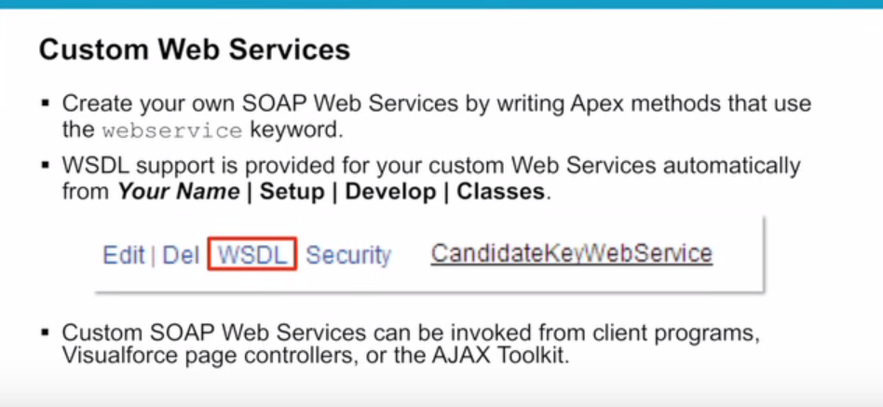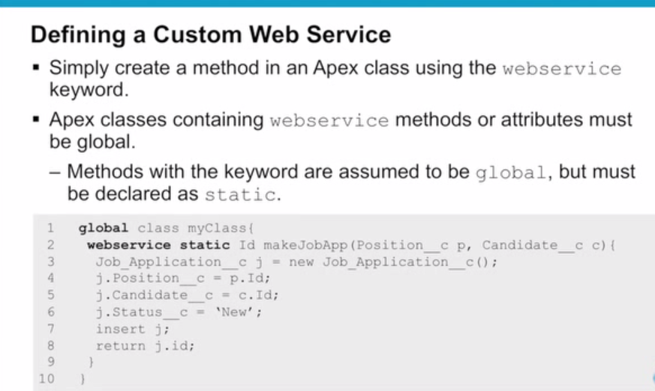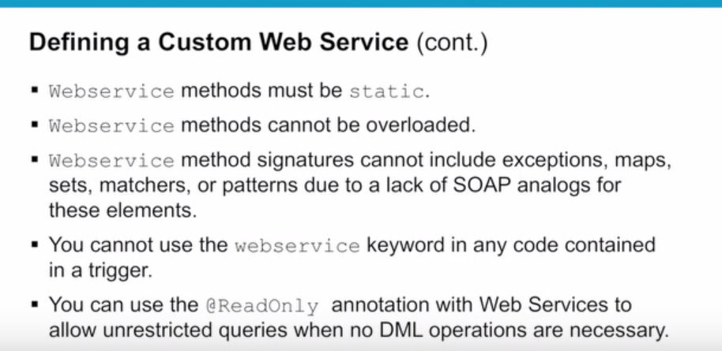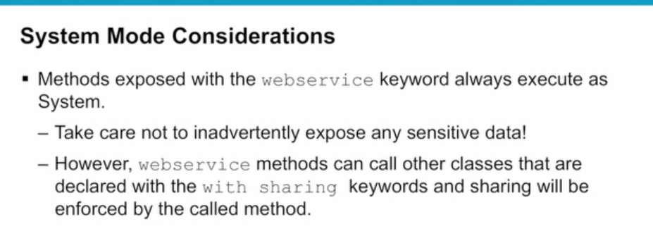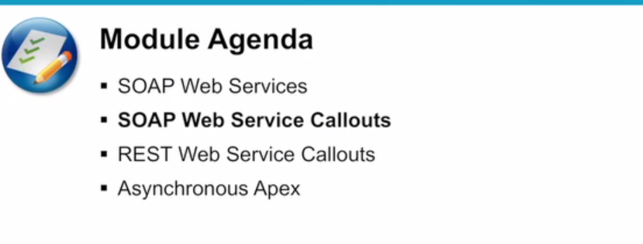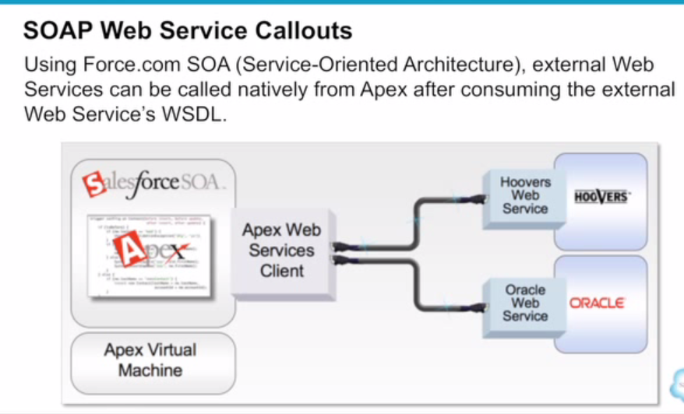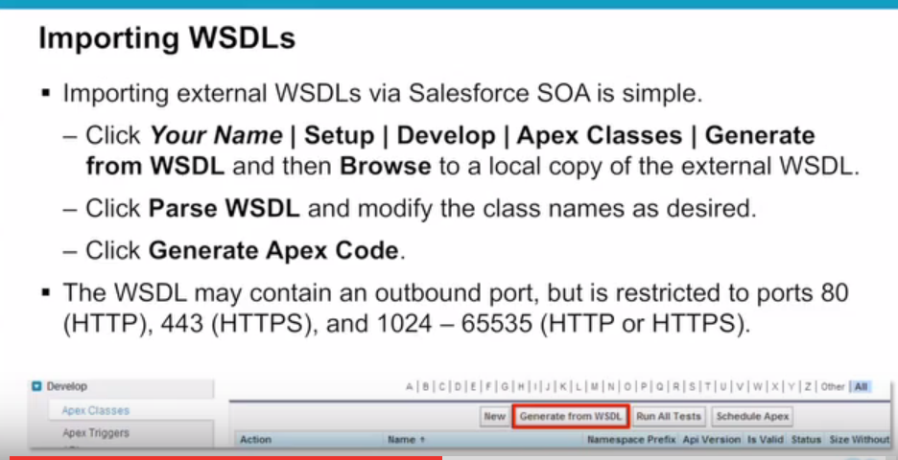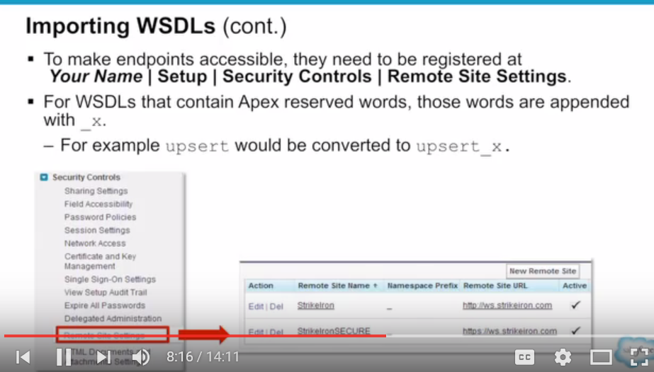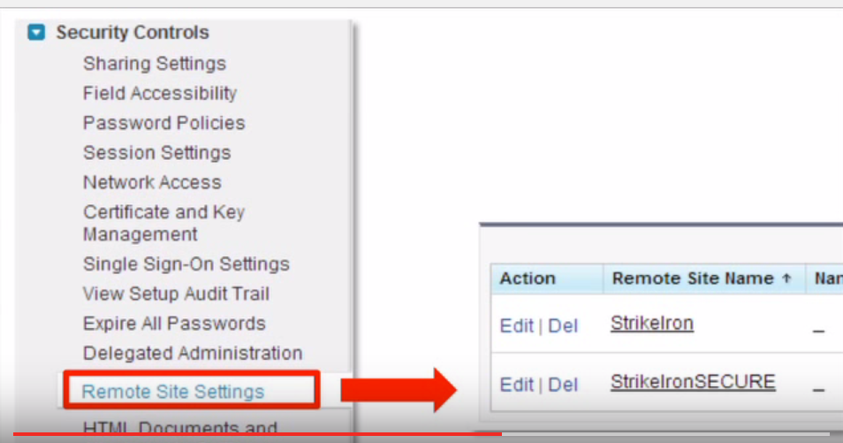

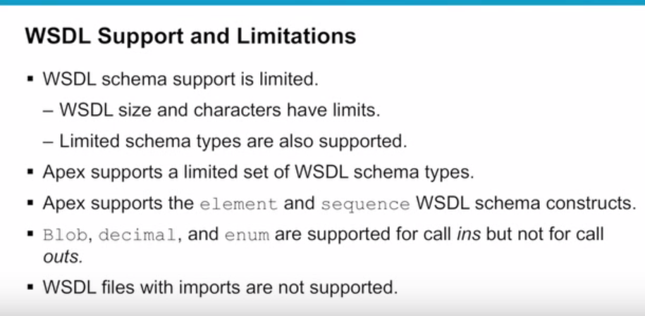

When you log on to a PC with a user name and password you are **authenticating**. **Authorization** is the process of verifying that you have access to something. Gaining access to a resource (e.g. directory on a hard disk) because the permissions configured on it allow you access is **authorization**.

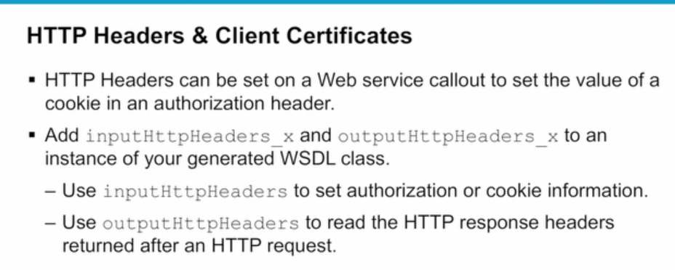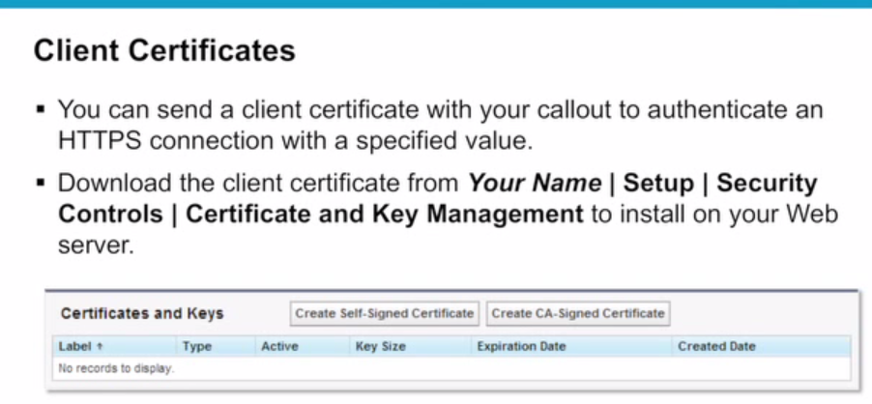

**SSL** is an acronym for **Secure Sockets Layer**, an encryption technology that was created by Netscape. **SSL** creates an encrypted connection between your web server and your visitors' web browser allowing for private information to be transmitted without the problems of eavesdropping, data tampering, or message forgery.

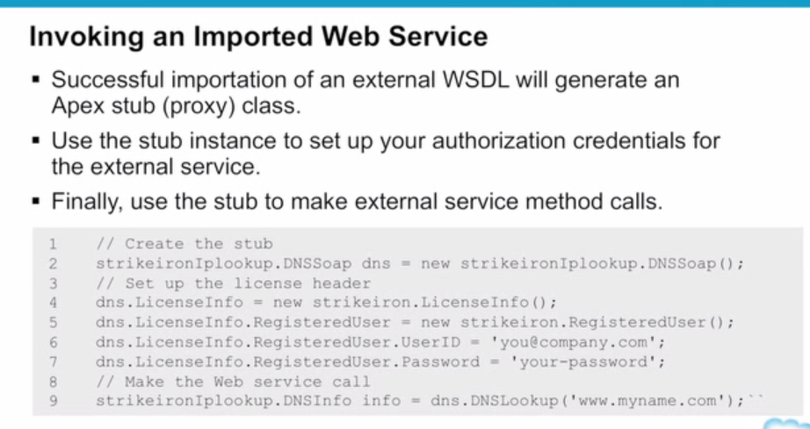

A **DNS server** is any computer registered to join the Domain Name System. A **DNS server** runs special-purpose networking software, features a public IP address, and contains a database of network names and addresses for other Internet hosts.

---------------------------------------------------------

**Proxy/Stub, by which they mean proxy or stub.**  
  
A proxy is a piece of code that doesn't perform any functions of its own, but instead is responsible for calling the real code. For instance you can use wsdl.exe (or Visual Studio) to generate a proxy class for a webservice. This class doesn't perform the function of the webservice, but it's responsible for calling the webservice.  
  
A stub is a placeholder, usually a class skeleton that you need to fill in yourself with real code. To again use the web service example: on the server you have a class using [WebService] that implements the service. Giving an existing WSDL contract, wsdl.exe can generate a stub for that service: a class that implements the service, but all the methods are empty leaving you to implement the functionality for real.  
  
Both proxy and stub code is most often auto generated, like in this example with wsdl.exe.

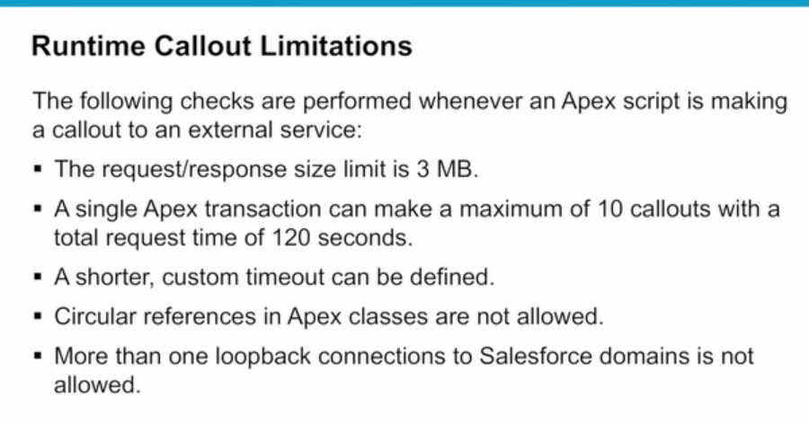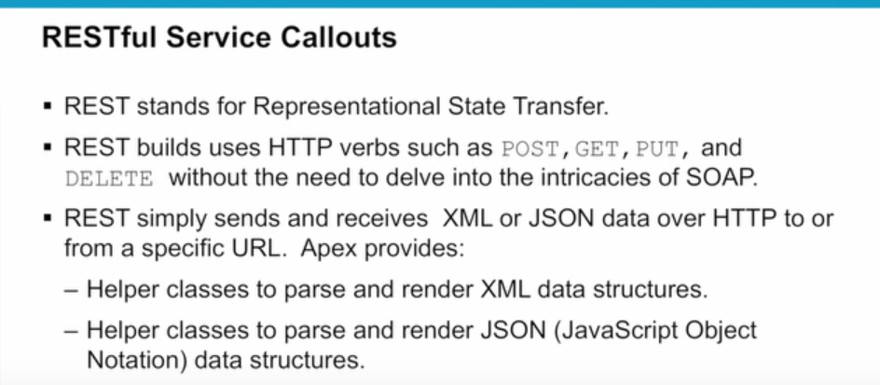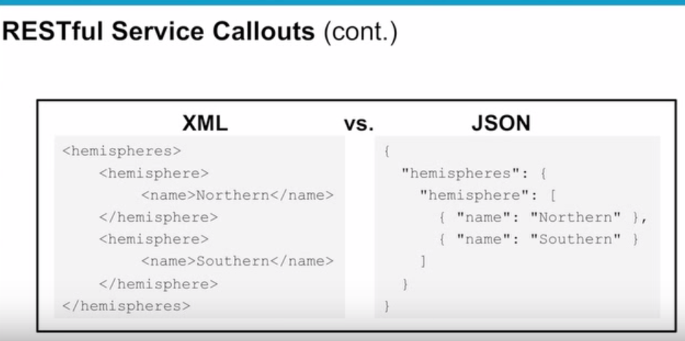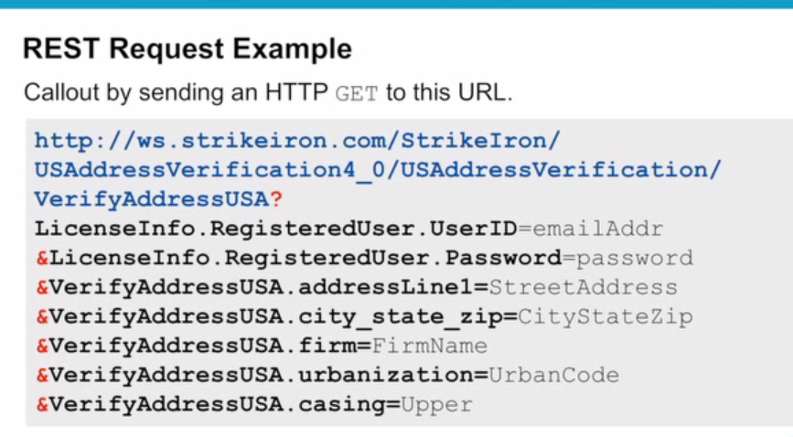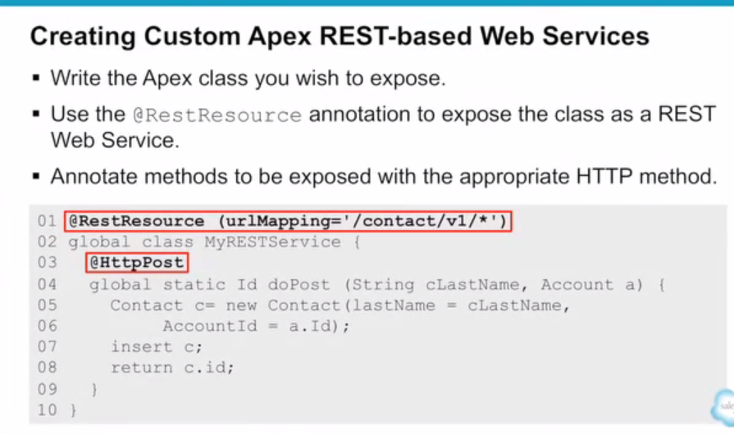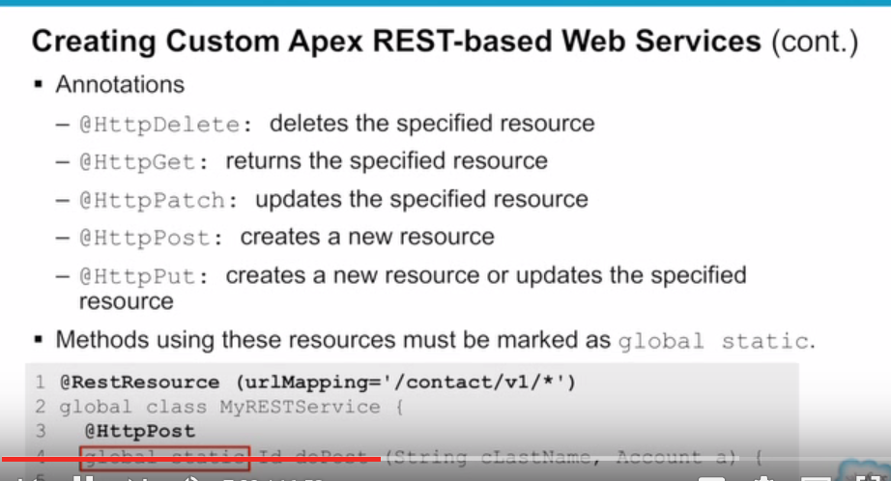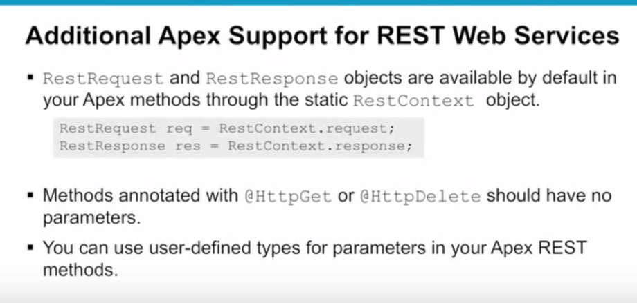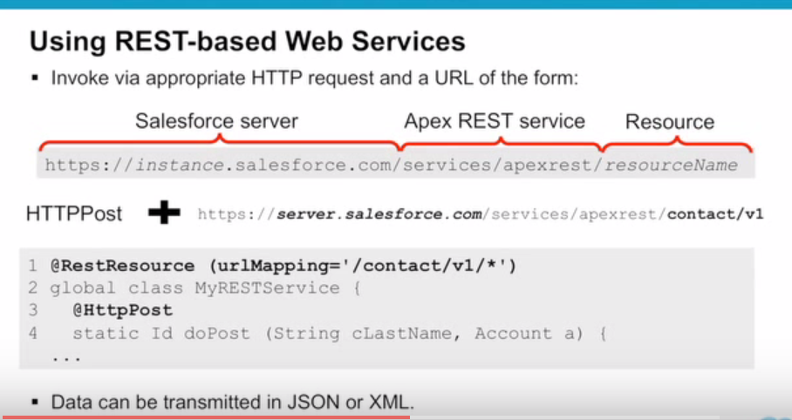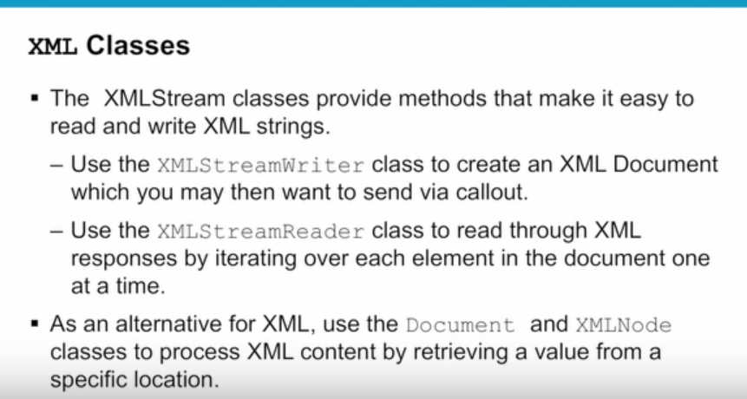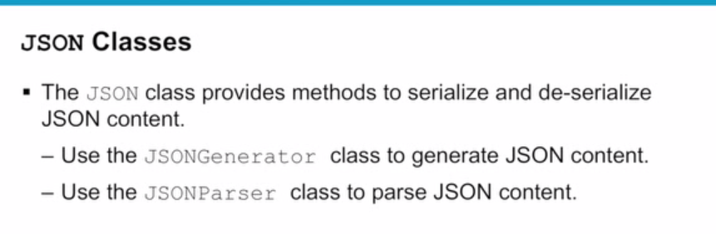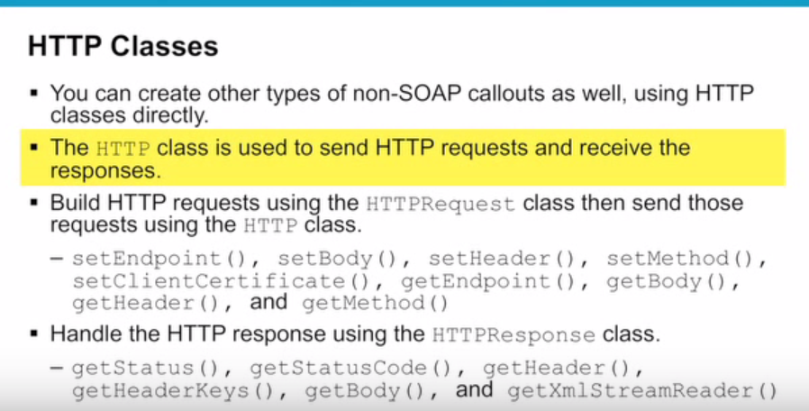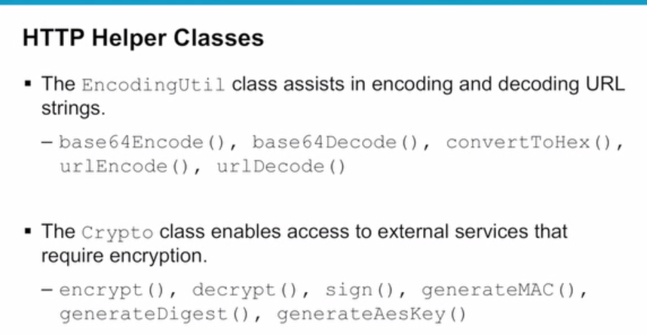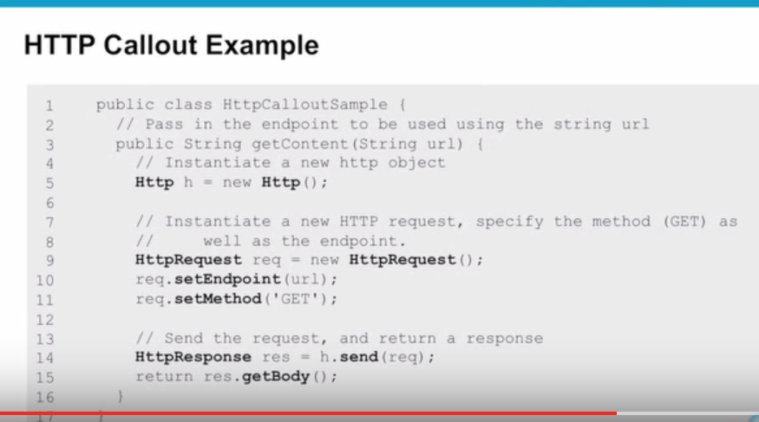

Use the [XML classes](https://developer.salesforce.com/docs/atlas.en-us.apexcode.meta/apexcode/apex_xml_dom.htm) or [JSON classes](https://developer.salesforce.com/docs/atlas.en-us.apexcode.meta/apexcode/apex_methods_system_json_overview.htm) to parse XML or JSON content in the body of a request created by [HttpRequest](https://developer.salesforce.com/docs/atlas.en-us.apexcode.meta/apexcode/apex_classes_restful_http_httprequest.htm#apex_classes_restful_http_httprequest), or a response accessed by [HttpResponse](https://developer.salesforce.com/docs/atlas.en-us.apexcode.meta/apexcode/apex_classes_restful_http_httpresponse.htm#apex_classes_restful_http_httpresponse).

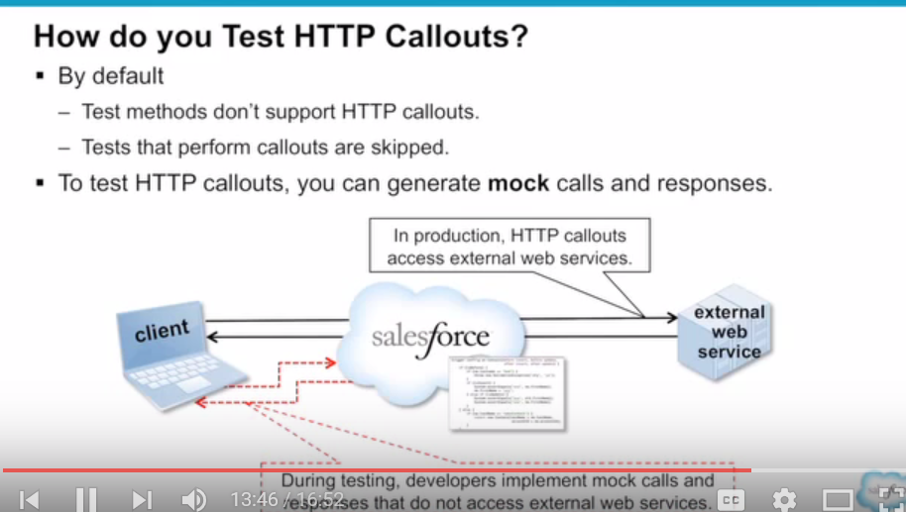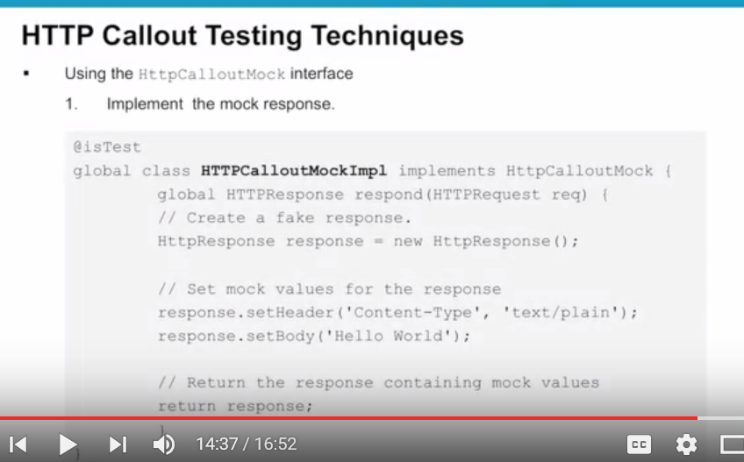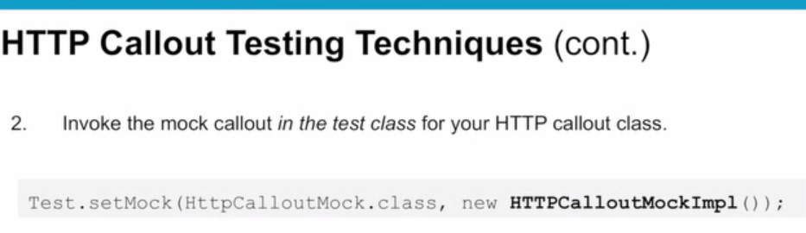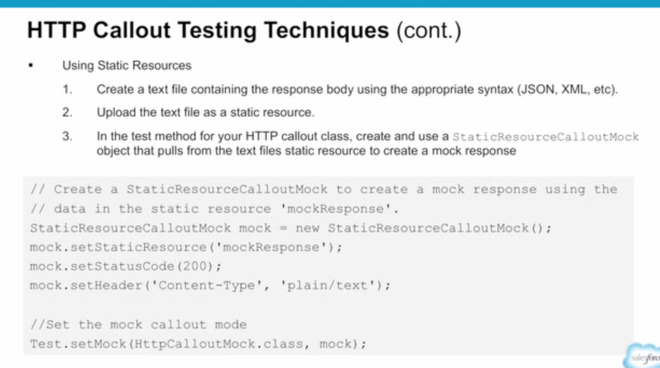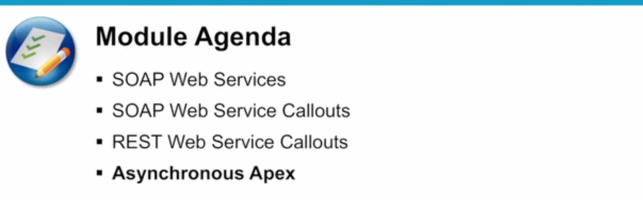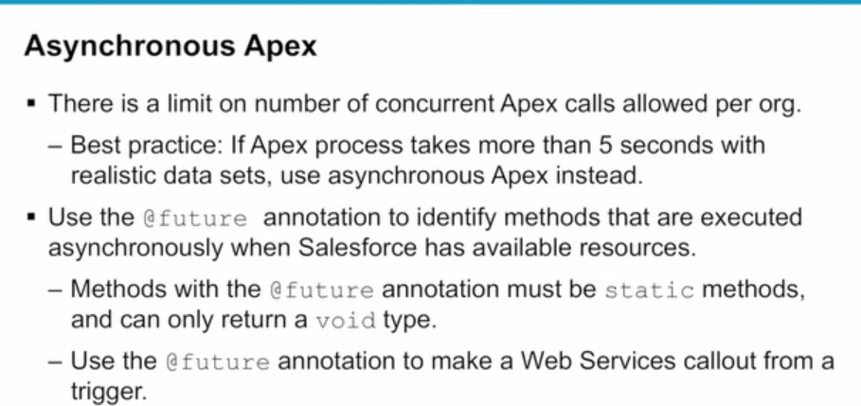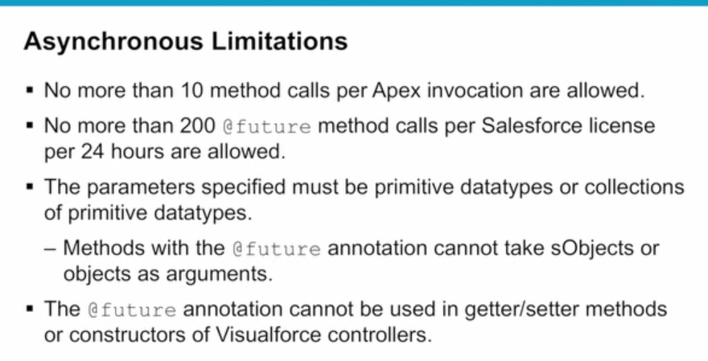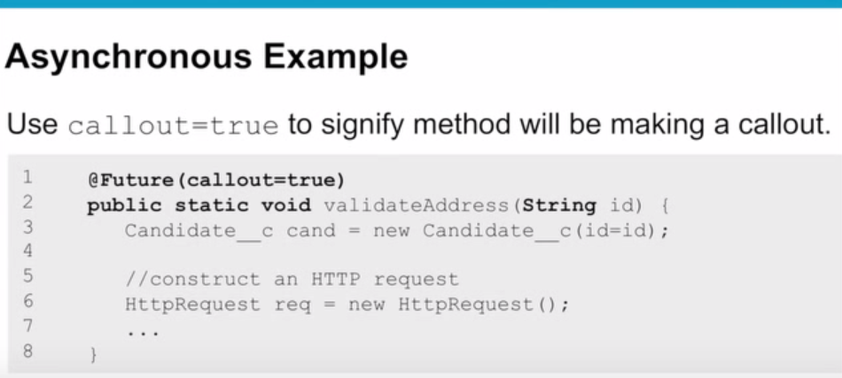

# Apex SOAP Callouts

## Learning Objectives

After completing this module, you’ll be able to:

* Generate Apex classes using WSDL2Apex.
* Perform a callout to send data to an external service using SOAP.
* Test callouts by using mock callouts.

## Use WSDL2Apex to Generate Apex Code

In addition to REST callouts, Apex can also make callouts to SOAP web services using XML. Working with SOAP can be a painful (but necessary) experience. Fortunately, we have tools to make the process easier.

WSDL2Apex automatically generates Apex classes from a WSDL document. You download the web service’s WSDL file, and then you upload the WSDL and WSDL2Apex generates the Apex classes for you. The Apex classes construct the SOAP XML, transmit the data, and parse the response XML into Apex objects. Instead of developing the logic to construct and parse the XML of the web service messages, let the Apex classes generated by WSDL2Apex internally handle all that overhead. If you are familiar with WSDL2Java or with importing a WSDL as a Web Reference in .NET, this functionality is similar to WSDL2Apex. You’re welcome.

#### Note

Use outbound messaging to handle integration solutions when possible. Use callouts to third-party web services only when necessary.

For this example, we’re using a simple calculator web service to add two numbers. It’s a groundbreaking service that is all the rage! The first thing we need to do is download the WSDL file to generate the Apex classes. [Click this link](https://th-apex-soap-service.herokuapp.com/assets/calculator.xml) and download the calculator.xml file to your computer. Remember where you save this file, because you need it in the next step.

### **Generate an Apex Class from the WSDL**

1. From Setup, enter Apex Classes in the Quick Find box, then click **Apex Classes**.
2. Click **Generate from WSDL**.
3. Click **Choose File** and select the downloaded calculator.xml file.
4. Click **Parse WSDL**. The application generates a default class name for each namespace in the WSDL document and reports any errors.

For this example, use the default class name. However, in real life it is highly recommended that you change the default names to make them easier to work with and make your code more intuitive.

It’s time to talk honestly about the WSDL parser. WSDL2Apex parsing is a notoriously fickle beast. The parsing process can fail for several reasons, such as an unsupported type, multiple bindings, or unknown elements. Unfortunately, you could be forced to manually code the Apex classes that call the web service or use HTTP.

1. Click **Generate Apex code**. The final page of the wizard shows the generated classes, along with any errors. The page also provides a link to view successfully generated code.

The generated Apex classes include stub and type classes for calling the third-party web service represented by the WSDL document. These classes allow you to call the external web service from Apex. For each generated class, a second class is created with the same name and the prefix Async. The calculatorServices class is for synchronous callouts. The AsyncCalculatorServices class is for asynchronous callouts.

### **Execute the Callout**

**Prerequisites**

Before you run this example, authorize the endpoint URL of the web service callout, https://th-apex-soap-service.herokuapp.com, using the steps from the [Authorize Endpoint Addresses](https://trailhead.salesforce.com/apex_integration_services/apex_integration_callouts.htm#apex_integration_callouts_authorizing) section.

Now you can execute the callout and see if it correctly adds two numbers. Have a calculator handy to check the results.

1. Open the Developer Console from the Setup gear ().
2. In the Developer Console, select **Debug** | **Open Execute Anonymous Window**.
3. Delete all existing code and insert the following snippet.
4. calculatorServices.CalculatorImplPort calculator = new calculatorServices.CalculatorImplPort();
5. Double x = 1.0;
6. Double y = 2.0;
7. Double result = calculator.**doAdd**(x,y);

System.**debug**(result);

Copy

1. Select **Open Log**, and then click **Execute**.
2. After the debug log opens, click **Debug Only** to view the output of the System.debug statements. The log should display 3.0.

## Test Web Service Callouts

All experienced Apex developers know that to deploy or package Apex code, at least 75% of that code must have test coverage. This coverage includes our classes generated by WSDL2Apex. You might have heard this before, but test methods don’t support web service callouts, and tests that perform web service callouts fail. So, we have a little work to do. To prevent tests from failing and to increase code coverage, Apex provides a built-in WebServiceMock interface and the Test.setMock method. You can use this interface to receive fake responses in a test method, thereby providing the necessary test coverage.

### **Specify a Mock Response for Callouts**

When you create an Apex class from a WSDL, the methods in the autogenerated class call WebServiceCallout.invoke, which performs the callout to the external service. When testing these methods, you can instruct the Apex runtime to generate a fake response whenever WebServiceCallout.invoke is called. To do so, implement the WebServiceMock interface and specify a fake response for the testing runtime to send.

Instruct the Apex runtime to send this fake response by calling Test.setMock in your test method. For the first argument, pass WebServiceMock.class. For the second argument, pass a new instance of your WebServiceMock interface implementation.

Test.**setMock**(WebServiceMock.class, new MyWebServiceMockImpl());

Copy

That’s a lot to grok, so let’s look at some code for a complete example. In this example, you create the class that makes the callout, a mock implementation for testing, and the test class itself.

1. In the Developer Console, select **File** | **New** | **Apex Class**.
2. For the class name, enter AwesomeCalculator and then click **OK**.
3. Replace autogenerated code with the following class definition.
4. public class AwesomeCalculator {
5. public static Double **add**(Double x, Double y) {
6. calculatorServices.CalculatorImplPort calculator =
7. new calculatorServices.CalculatorImplPort();
8. return calculator.**doAdd**(x,y);
9. }

}

1. Press **CTRL+S** to save.

Create your mock implementation to fake the callout during testing. Your implementation of WebServiceMock calls the doInvoke method, which returns the response you specify for testing. Most of this code is boilerplate. The hardest part of this exercise is figuring out how the web service returns a response so that you can fake a value.

1. In the Developer Console, select **File** | **New** | **Apex Class**.
2. For the class name, enter CalculatorCalloutMock and then click **OK**.
3. Replace the autogenerated code with the following class definition.
4. @isTest
5. global class CalculatorCalloutMock implements WebServiceMock {
6. global void **doInvoke**(
7. Object stub,
8. Object request,
9. Map<String, Object> response,
10. String endpoint,
11. String soapAction,
12. String requestName,
13. String responseNS,
14. String responseName,
15. String responseType) {
16. // start - specify the response you want to send
17. calculatorServices.doAddResponse response_x =
18. new calculatorServices.**doAddResponse**();
19. response_x.return_x = 3.0;
20. // end
21. response.**put**(**'response_x'**, response_x);
22. }

}

Copy

1. Press **CTRL+S** to save.

Lastly, your test method needs to instruct the Apex runtime to send the fake response by calling Test.setMock before making the callout in the AwesomeCalculator class. Like any other test method, we assert that the correct result from our mock response was received.

1. In the Developer Console, select **File** | **New** | **Apex Class**.
2. For the class name, enter AwesomeCalculatorTest and then click **OK**.
3. Replace the autogenerated code with the following class definition.
4. @isTest
5. private class AwesomeCalculatorTest {
6. @isTest static void **testCallout**() {
7. // This causes a fake response to be generated
8. Test.**setMock**(WebServiceMock.class, new CalculatorCalloutMock());
9. // Call the method that invokes a callout
10. Double x = 1.0;
11. Double y = 2.0;
12. Double result = AwesomeCalculator.**add**(x, y);
13. // Verify that a fake result is returned
14. System.**assertEquals**(3.0, result);
15. }

}

Copy

1. Press **CTRL+S** to save.
2. To run the test, select **Test** | **Run All**.

The AwesomeCalculator class should now display 100% code coverage!

